# Radiomics

## Introduction

As explained previously, there are globally two ways for establishing a diagnosis of diseases such as liver cancers: the biopsy, or the diagnostic imaging.

The biopsy, as detailed earlier, suffers from a lot of drawbacks. It remains an invasive procedure, with a high cost in terms of resources, and does not consider the tumor heterogeneity.

The diagnostic imaging on the other hand, is not invasive, provides information about the tumor shape, the growth over the time, and is less prone to bias due to tissue heterogeneity.

The recent improvements in the medical imaging field allow acquisition of data being more and more relevant, thus enabling a better estimation of the phenotypical characteristics of the patients.

In the case of brain imaging, the augmentation of contrast, on MR images, thanks to the injection of contrast agents such as gadolinium-based agents (method mentioned before) is an important technique for the evaluation of brain and liver tumors [**ref 6,7 HT report + ref** [**Thian et al. 2013**](https://www.ncbi.nlm.nih.gov/pmc/articles/PMC3893895/#:~:text=Liver%2Dspecific%20magnetic%20resonance%20(MR,tree%20anatomy%20and%20liver%20function)]. This tool allows a delineation of large tumors and an early detection of small metastatic lesions. The different MRI sequences (e.g. the T1 weighted sequences) also allow an internal separation of the tissue within the same tumor (active vs necrotic part of the tumor) [**ref 6 HT report**].

Support brought by the innovations in the medical imaging field have been demonstrated on other organs such as the liver [**ref 8 HT report**], the breast [**ref 9 HT report**] or the colon [**ref 10 HT report**] with a consequent benefit in terms of diagnosis.

However, even though the advancements in the medical imaging fields allowed those performances, the interpretation of the medical images remains subjective and not quantitative. In order to correctly provide a diagnosis that will not depend on the observer, one can extract and use the characteristics previously difficult, even impossible to distinguish with the naked eye.

Introduced in the 80s, *CAD* (Computer Assisted Diagnosis) tools were the first to implement this method, to establish a link between the imaging features and the biological characteristics of the patients [**ref 11 HT report**].

In order to go along with those new systems, standard were introduced such as the one created by the *WHO* or the *RECIST* [**ref 12 HT report**], were the objective was to assess the evolution of the disease following the progression of the tumor size, but here again, those criteria suffer from a too high dependence with the observers.

The term *radiomics* was introduced in the early 2010s, allowing the computation of more features than the traditional *CADs* (more than a thousand vs only a dozen previously) and bringing a more complete diagnosis, since *CADs* were often limited to distinguish benign vs malignant lesions [**ref 13 HT report**].

This new technique allows some breakthroughs in various applications such as the cancer diagnosis, the detection of the tumors (with the identification of malignant lesions), their classification, the estimation of the patient survival, the prediction of the aggressivity of the tumors, their recurrence, or the advancement of the disease.

In the clinical practice, this new method also allows an improvement in the way biopsies are performed, with the identification of the areas where the extraction should be performed [**ref 14 HT report**] or even by prediction when a biopsy is helpful or not [**ref 15 HT report**].

Compared to above-mentioned criteria based on a naked-eye examination, we are now able to rely on a computer to analyse the gray-levels at a finer scale. Therefore, 2 approaches exist, the *HCR* (Hand-Crafted Radiomics) based on mathematical engineered features, relying on the textural and intensity based properties of the volume of interest, and the *DLR* (Deep-Learning radiomics), where the retained features will directly be computed from the input data without any prior knowledge.

## Handcrafted Radiomics

In this section we will describe the *HCR* pipeline, by first exposing the different steps of the classical workflow, before analysing the different studies that used *HCR* on patients suffering from *HCCs*. We will conclude with the different improvements that should be brought to enhance the power of radiomics.

A conventional radiomics workflow (based on *HCR* features) starts with the acquisition and the reconstruction of medical images, followed by the segmentation of those images, which is a critical step since *HCR* features are extracted from the segmented sections, and many tissues do not have distinct boundaries [**ref 3 of Afshar et al. 2018**]. Once the different areas segmented, the features are extracted and quantified, and a statistical analysis is performed to select only the most relevant one. The final step consists in building a model that will use the selected features to perform the wanted task, which is often either the tumor characterization or its prognosis. The pipeline is illustrated in the figure below [**ref Scrinever et al. 2016**].

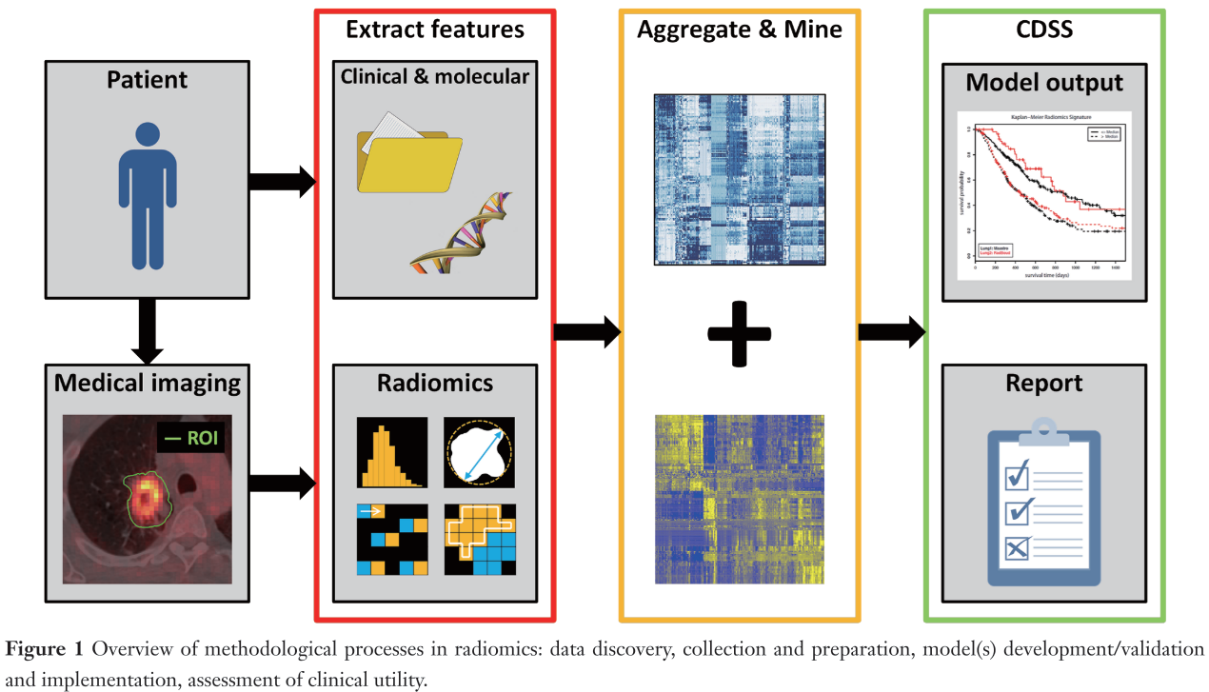

We will now describe those different steps, before analyzing recent state-of-the-art *HCR* studies, before establishing a list of measures needed to be taken in order to improve the quality and the reproducibility of future radiomics works.

### HCR workflow

As explained previously, ultrasonography (US) is the recommended modality as primary imaging test for surveillance. If the surveillance is positive, CT or MR examinations are performed for the diagnosis and the staging of the disease. For the reasons exposed previously, namely the availability, and its robustness when compared to MRI, we will focus on *HCR* studies based on CT imaging data.

Without entering into the details of how a CT scan works, we can assume that performances of the CT imaging depend mainly on some settings such as the slice thickness, the capability for projecting the density variations into image intensities and the reconstruction algorithm which aims at converting tomographic measurements into cross-sectional images.

It has been demonstrated that radiomics features can differ between different scanners with the same settings [**ref 24 of Afshar et al. 2018**]. It is also common to differentiate CT images into two categories, the screening where low dose images are used and the diagnosis with higher quality of contrast obtained with higher doses [**ref 25 of Afshar et al. 2018**]. Worth mentioning that the majority of the studies that are being investigated belong to the second category.  
Images are typically combined with other clinical sources when computing the radiomics features. Among them, gene expressions, clinical data such as the age, the gender or the past medical history, blood biomarkers or other prognostic markers such as the tumor size, the stage or the recurrence are the main non-imaging sources of data that are used in the radiomics workflow. However, they can be difficult to acquire, normalize and integrate in a radiomics pipeline, therefore, features are most commonly extracted from images only.

#### Segmentation

Historically, the segmentation was performed manually, hence, sensitive to the inter-observer variability, as depicted below [**ref Echegaray et al. 2015, ref Bakr et al. 2017**].

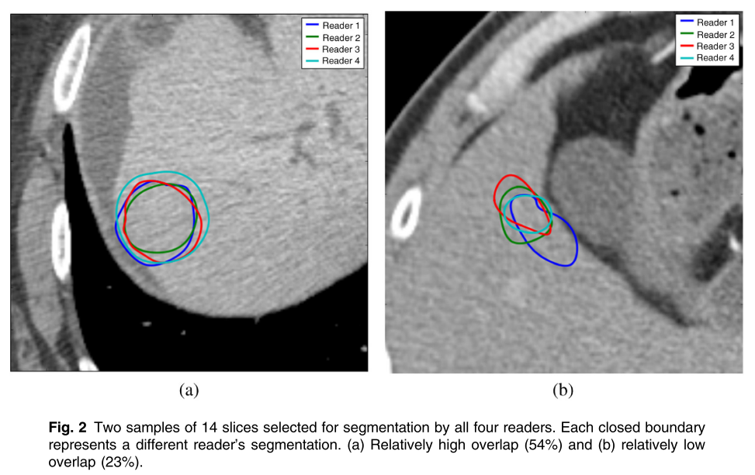

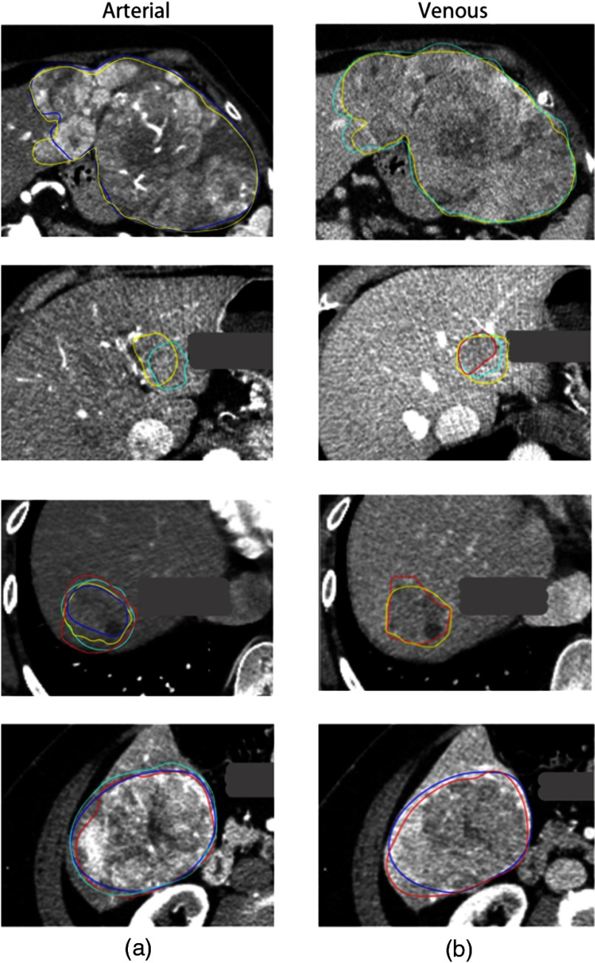

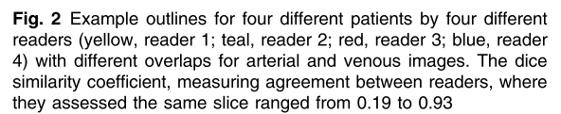

To reduce this bias, semi-automatic segmentation techniques were developed. Those based on the intensity of the pixels suffer from the fact that the intensity of the pixels, in the case of abdominal organs, is often close from one organ to another. On the other hand, models based on statistical models often require the computation of an energy function, that can involve a large number of parameters, thus being difficult to compute and optimize.  
(More details concerning the liver semantic segmentation techniques can be found in the appropriate section [**see Sem. Seg. chapter**]).  
Once the volume of interest delineated, different features can be extracted. On one hand, features can be chosen a priori for their capacity to translate the physiological behavior expected by the experts. For example, studies performed on the lungs showed a correlation between the textural homogeneity and the survival of the patients [**ref 17, 18 of HT report**], or the grade [**ref 19**]. This knowledge can also be used in the case of brain tumors to assess the response to a treatment, by observing for example the vascular or cellular density [**ref 20, 7 HT report**]. However, a prior knowledge is not always for the wanted task, therefore, the alternative is to extract a huge quantity of features and to determine the most relevant one by using for example some machine learning algorithms.

#### Features

Features can be regrouped into different categories depending on their statistical order (first, second or higher order). For the features belonging to the first statistical order, the volume of interest is transformed into an histogram, and different values are computed such as the uniformity or the entropy. Even though those features are often sensitive to the acquisition settings such as the slice thickness or even the way the histogram is computed, they permitted the prediction of the malignancy of breast lesions [**ref 21 of HT report**].   
Shape features are often extracted directly from the VOI in order to analyze its geometrical properties (such as the overall volume occupied by the tumor, its sphericity, its roughness or its fractal dimension). Those features also permitted the prediction of the response to treatment in previous studies [**ref 22 of HT report**].

Second order statistical features are meant to extract the textural properties of the volume, by considering the neighboring relationship between pixels. This will play an important role especially for the characterization of the heterogeneity of the tissues. This relation is captured by several descriptive matrices (*GLCM*, *GLRLM*, …) [**ref 21 of HT report**].   
Finally, higher order features allow the extraction of imaging features in various frequency domains (the Wavelet features are the most commonly used higher order features [**ref 22 of HT report**]).

#### Features Selection

As listed here, a large quantity of features can be extracted and they tend sometimes to be highly correlated, which in some cases can cause overfitting during the creation of a predictive model. A diminution phase of the number of features is often required, either in a supervised manner (features are selected for their discriminant power in regards with the wanted task) or in non-supervised manner (the main objective is to suppress the redundant features without considering the different labels) [**ref 21 HT report**].

Among the supervised methods, one can distinguish the univariate ones, where the features are tested one by one depending on their contribution to the wanted task (Wilcoxon or Fisher test), from the multivariate where the features are regrouped into subsets before being tested against the output class.

Unsupervised methods (such as the *PCA*: principal component analysis) are less prone to overfitting since they do not consider the label of the data, but their main goal is to reduce the dimensionality of the features space.

Once the number of features is reduced, the next step is to construct a predictive model, by using either clustering methods (patients are regrouped based on a metric depending on the retained features) or classification ones (where models such as *RF*: random forests or *SVM*: support vector machines are trained from the selected features in order to predict the wanted clinical criteria). Concerning the prediction of the survival, it is common to implement slightly different models such as the *Kaplan-Meier* or the *Cox Proportional Hazard* [**ref 23 HT report**].

In the radiomics studies, one of the main goals is the stability of the features against the pre-treatment steps described above. In order to reach this objective, it is possible for the patients to undergo the medical imaging examinations several times (*test-retest*), and the segmentations can be performed by several experts or even by the same expert several times [**ref 24 HT report**].

In summary, when dealing with classical radiomics pipelines, reaching the best results will often depend on the best combinations between the extraction of the features, the technique used to reduce the number of features and the method implemented to create the model.

Every modification on the cited steps can have a huge impact on the predictable performances of the created model.

In the next section, we will analyze the different *HCR* studies performed on patients suffering from *HCC* and who underwent CT examination. We will first describe the different choices made in each step of the classical pipeline, before presenting ways to improve the quality of future *HCR* work.

### HCR applied to the liver

In order to analyze the different methods implemented in the *HCR* field, 15 studies performed on patients suffering from HCC and who underwent CT scan examination were reviewed. Initially, 23 primary liver cancer-related studies have been scanned in our review [**ref TAIGA**], we then selected the 15 HCC-related ones.

We will first describe the different targets of the studies and the details of the cohorts through the number of patients and the clinical criteria that preceded their selection.

We will then compare the different imaging acquisition protocols, and the way the regions/volumes of interest are delineated. Finally, we will analyze the different features that appeared to be relevant in the studies, before proposing some tracks to improve the reproducibility and the performances of future radiomics work.

Details concerning the experimental settings of the studies, the endpoints and the different endpoints can be found in the following table ([link](https://docs.google.com/spreadsheets/u/0/d/10EHNALN2_6ZavU7049n6CwTfJO_vd6WBod64u8YNbHg/edit)).

#### Experimental setup

The vast majority of the studies were designed to predict the survival of the patients after surgery, or any other type of treatment [**Cozzi, Akai, Chen, Li, Banerjee, Segal, Zheng, Xia**]. In clinical trials, the traditional way to evaluate the survival is through the OS (Overall Survival), which corresponds to the duration from either the date of diagnosis of the disease or the start of its treatment, to either the end of the trial or the death of the patient. Being often assimilated to the survival rate, new finer metrics tend to be preferred such as the DFS (Disease Free Survival), which corresponds to the duration from the beginning of the treatment to the date of the recurrence of the disease.

Other ways to evaluate the response to a given treatment were also evaluated in some of the reviewed studies, such as the presence or absence of recurrence [**Zhou, Zheng**], the local control which assess the end of the growth of a tumor [**Cozzi #1**], and other ways to compute the sensitivity to a treatment [**Kuo #19, Li #24**].

Another important aspect that is often assessed by the reviewed studies is the physiological changes brought by the disease, such as the aggressive profile of the tumor, usually translated by the presence of *MVI* (MicroVascular Invasion), and its association to genes expression [**Kuo, Banerjee, Renzulli, Segal, Peng, Bakr, Taouli**].

The entire 15 studies had a retrospective design, and the number of selected patients varied from 28 [**ref Bakr #42**] to 319 [**ref Zheng #40**], with a median of 125 patients per study.

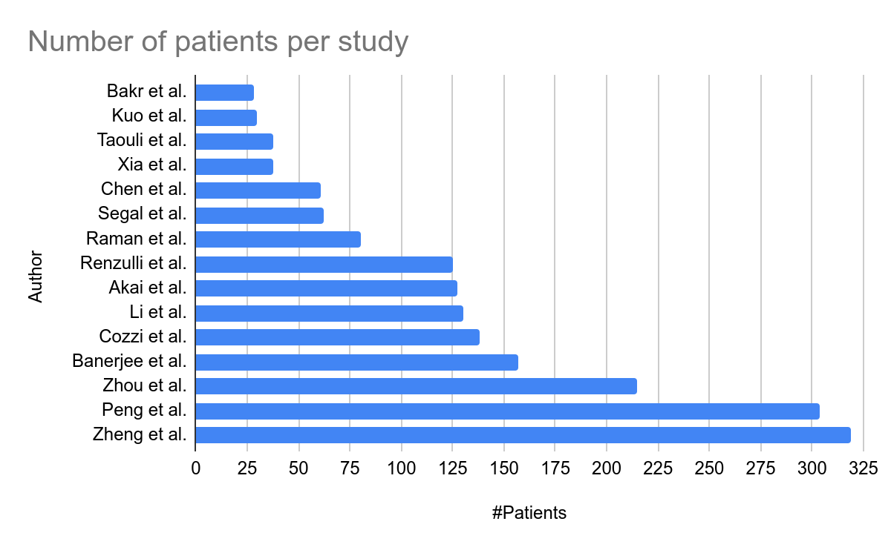

The relatively low number of patients can be explained by the strong inclusion criteria set within the studies (size and number of lesions, baseline imaging examination within a given period of time before initial treatment, …)

They were all built with data acquired on patients who underwent CT examination, except one, that decided to mix data obtained from both CT and MR examinations [**Taouli et al. #45**].

Regarding the CT scan protocol, only one study decided to use images acquired before the injection of contrast medium [**ref Cozzi #1**], whereas two other studies used images acquired at only one phase (early arterial phase for **Raman et al. #26**, and portal venous phase for **Li et al. #24**), and the remaining studies analyzed multiphase images. Among them, four studies utilized images acquired at both early arterial and portal venous phases [**ref Zhou #2, Chen #23, Kuo #29 and Zheng #40**], while the rest were based on traditional triphasic images [**ref Akai, Banerjee, Renzulli, Segal, Peng, Bakr, Taouli and Xia**]. Concerning the acquisition protocols, early arterial phase images are most of the time acquired around 30s after the injection of contrast agent (between 22 and 35s), and some studies used bolus tracking method to estimate the best acquisition moment instead of using the same timing for all the patients. Portal venous phase images are acquired between 45 and 70s after the injection, and the delayed images obtained during an even larger interval (between 90 and 300s after the injection).   
Knowing that images are the key elements in the computation process of the radiomics features, this high variation within the acquisition protocols is the first reason why the standard *HCR* pipeline should be standardized.

Once the images acquired, the following step consists in selecting the region of interest to compute the features, or evaluate the physiological properties of the lesions to the naked eye.

#### ROI selection

The selection of the region/volume of interest and/or the assessment of the physiological characteristics of the tumor is often performed by one or multiple experienced radiologists.  
This step of the pipeline was performed by only a single expert in rare cases in the reviewed studies [**Xia, Akai**], whereas it was usually performed by two experts [**Zhou, Chen, Li, Raman, Kuo, Renzulli, Segal, Zheng, Peng, Taouli**].  
When more than 1 expert is involved, the authors decided to implement ways for quantifying the inter and intra-observer variability, such as the *ICC* (Intraclass Correlations Coefficient) [**Zheng, Li**], or the Cohen k statistics [**Banerjee, Renzulli**].

Regarding now the selection of the ROI, we can separate the reviewed studies by the type of features being extracted.

On one hand, when using imaging traits, it is common to use the whole tumor to perform the evaluation. For example when evaluating the vascular invasion, some features like the peritumoral enhancement need to be estimated globally [**Renzulli et al., Banerjee et al., Segal et al., Kuo et al.**].  
On the other hand, when using computational features, the analysis can be performed on the whole tumor or on a single slice. Some studies decided to compute the features on the entire 3D ROI, as an example **Cozzi** **et al.** used the entire tumor independently on the tissues present within it, **Xia et al.** decided to separate areas based on their textural properties as depicted below, but the analysis remains global. Other studies placed everal ROIs all throughout the tumor (3 ROIs for **Bakr et al.** and from 5 to 10 for **Raman et al.**). However, the majority of the studies decided to place the ROI at the largest cross-sectional area [**Li, Chen, Zhou, Akai, Zheng**].

|  |  |
| --- | --- |
|  | [**Xia et al.**]  Figure 2. Illustration of intratumor partition for two representative patients (TCGA-DD-A1EB and TCGA-BC-A69H). The first column shows the tumor outlines on the original CT image. The second column shows the heatmaps of calculated local entropy on tumor images. The third column shows the three subregions marked with different colors after intratumor partitioning. |

Note that some studies decided to compute the features using both the entire volume and the slice-wise approach (e.g. **Taouli et al.** evaluated imaging traits globally and computed the ratio using a slice-wise fashion, **Peng et al.** did the same in their study by computing features using an ROI placed at the largest-cross sectional area, and evaluating imaging traits globally).

Worth mentioning that before the computation of features, it is common to filter the images using different kernel sizes, in order to enhance different elements of the volumes such as the blood vessels for example. All reviewed studies that computed quantitative features filtered their images with a Laplacian of Gaussian algorithm with various sizes, as depicted below [**Akai et al.**].

|  |  |
| --- | --- |
|  | [**Akai et al.**]  Figure 2. Screenshot of the CT texture analysis software. A polygonal ROI was drawn on the tumor (a). Processed images using Laplacian of Gaussian filters with SSF of 2 mm (b), 4 mm (c), and 6 mm (d) were automatically generated. The images were displayed using a red or blue scale showing negative or positive pixels, respectively. |

#### Features selection

Once the ROI delineated and pre-processed, the following step consists in extracting the features, and as explained previously, the choice on which features to extract depends on the type of features the study is going to rely on, quantitative or semantic.

In the case of quantitative features, the reviewed studies often decided to focus on a single category of features (first-order, textural features, higher-order…), thus obtaining a relative small number of features (27 for **Li et al.**, 32 for **Raman et al.**). However, despite choosing a specific category of features, this number can increase, when combining the native features with the spatial filter, and the different contrast enhanced phases, as in **Akai et al.** where a total 96 features are extracted from the initial 6 histogram-based features.

Some other studies decided to extract the maximum possible features by combining the previously mentioned group of features, and thus obtained 300+ features, [**Zhou et al.**, **Peng et al., Bakr et al.**]. The problem in this case, often called “*curse of dimensionality*”, corresponds to a high number of features relative to the number of individuals, and that can cause some troubles when further training the predictable model.

When imaging traits are preferred to classical radiomics features, the number of extracted characteristics is generally below 10, with a high predominance of changes brought by the hepatocarcinogenesis, such as the presence of internal arteries, or the wash-in wash-out effect (example of imaging traits can be observed in the following figure). Even though the number of extracted features is often small, they often correspond to absence or presence of physiological properties that are sometimes difficult to quantify and that will highly depend on the observer's experience.

|  |  |
| --- | --- |
|  |  |
| [**Segal et al.**]  From top to bottom:  Internal arteries  Hypodense halo  Textural heterogeneity | [**Taouli et al. - Figure 1**]  (a,b) wash-in/wash-out pattern and mosaic appearance, without capsule/ pseudocapsule.  (c) internal arteries (arrows)  (d) pseudo-capsule (arrow)  (e) [MR image] hyperintense encapsulated with mosaic appearance (arrow)  (f) internal necrosis and satellite lesions posteriorly (dashed arrow)  (g) right portal vein invasion (dashed arrow)  (h) extra-nodular growth anteriorly (dashed arrow) |

After the different features are obtained, the next step in the pipeline consists in the selection of the features and the building of the predictive model.

The vast majority of the reviewed studies decided to implement a logistical regression model in order to assess the correlation between features and the study endpoint. Among the existing methods, time-related approaches such as the Cox regression model [**Li, Banerjee, Zheng, Cozzi, Xia**] and the Kaplan-Meier survival analysis [**Segal, Chen, Akai, Xia**] are the most commonly used, especially because those are historical ways to predict the survival of the patients.

Different statistical approaches were used by the studies that tried to determine the link between selected features and study endpoints such as the *LASSO* (Least Absolute Shrinkage and Selection Operator) algorithm [**Zhou, Peng, Bakr**]. In the other studies, other approaches were implemented, for example, **Raman et al.** performed a *PCA* (Principal Components Analysis) followed by a *MANOVA* (Multivariate Analysis Of VAriances) to create clusters among patients for the classification of hypervascular lesions, whereas **Renzulli et al.** evaluated the positive and negative predictive values of the selected features against the microvascular invasion status of the patients.

The list of discriminant features per study is given in the tables below, with a separation between quantitative and semantic features.

|  |
| --- |
| **Quantitative Features** |
| *First Order Statistics*   * Shape [Cozzi] * Skewness [Akai, Li, Zhou] * Kurtosis [Akai] * Mean [Zhou, Raman, Cozzi] * Energy [Zhou, Cozzi] * Entropy [Peng, Akai] * Peak [Bakr] * Standard deviation [Xia] * Enhancement ratio [Taouli] * Tumor-Liver difference [Taouli] |
|
| *Second Order Statistics*   * Gray Level matrices [Peng, Zheng, Cozzi] * Cluster prominence [Xia] |
|
| *Higher Order Statistics*   * Wavelets [Chen, Li, Bakr] * Gabor [Chen, Bakr] |
|
| *Morphological features*   * Tumor margin volume [Xia] * Tumor size* [Renzulli, Taouli] |
|

* Tumor size in the two studies is not given as the exact volume, but rather a classification of tumors in different categories (for example the categories were smaller than 2cm, between 2 and 5 cm, and larger than 5 cm in **Renzulli et al.**)

|  |
| --- |
| **Semantic Features** |
| *Two Traits Predictor of Venous Invasion*   * Internal arteries [Renzulli, Kuo, Peng, Segal, Banerjee, Taouli] * Hypoattenuating halos [Renzulli, Peng, Segal, Banerjee] |
|
| *Intensity-related features*   * Peritumoral enhancement[Renzulli] * Presence of a Tumor-Liver difference [Banerjee] |
| *Textural-related features*   * Non-smooth Tumor Margins[Renzulli, Kuo, Peng] * Infiltrative patterns [Taouli] * Mosaic appearance[Taouli] |

Concerning the studies based on quantitative features we can notice that first-order statistical features is the most common discriminant type, which is normal because this group of histogram-based characteristics is often implemented in the existing radiomics tools, whereas higher order statistical features require more advanced knowledge to be implemented, and often lack of interpretability.

Even though **Li et al.** decided to extract only Wavelet features because they consider that the current way of computing textural features is too dependent on the imaging acquisition settings, first and second-order statistical features remain a good indicator of the textural heterogeneity which is often correlated with the physiological advances of the disease.

Worth also noting that imaging traits, often analyzed either alone, or in combination with quantitative features, remain discriminant enough in a lot of studies, because they are directly linked to the physiological changes produced by the disease. Despite needing expertise to be extracted, such as in **Segal et al**. where 32 different imaging traits were analyzed, their predictable power drives us to consider them in future radiomics studies and focus on a way to quantify them.

#### Study reproducibility

Although the majority of the reviewed studies obtained good predictable results in regards with the wanted prediction task, their stability to the experimental settings and their reproducibility remain questionable.

In 2017, **Lambin et al.** who remains one of the founders of the radiomics fields [**ref Lambin 2012**] published a study proposing a way to rethink the HCR pipeline and assess the robustness of future radiomics studies [**ref Lambin 2017 RQS**]. This assessment is performed thanks to the *RQS* (Radiomics Quality Score), which evaluates a total of 16 components with various weights. The evaluation of the different components allows the computation of a score ranging from 0 to 36 points where highest weights are given to criteria allowing a better reproducibility of the study, such as the prospective aspect of the study (7 points over 36) or the presence of a validation step in the proposed workflow (5 points over 36, with a penalty of 5 points when no validation at all is present).

Our reviewed studies were evaluated in regards with the *RQS*, in consensus with a medical research fellow (Wakabayashi Taïga) [**ref Wakabayashi 2019**].

The different scores per study can be found in the following table ([link](https://docs.google.com/spreadsheets/u/0/d/10EHNALN2_6ZavU7049n6CwTfJO_vd6WBod64u8YNbHg/edit)).

The mean obtained *RQS* by the reviewed studies was 8.73 +/- 5.57 points, which corresponds to less than 23% of the maximal possible score, and only one study obtained a more than 50% of the maximum points, which translates the lack of robustness of the current *HCR* state-of-the-art studies applied to the *HCC*.

The table below allows us to see the most respected criteria in regards with the RQS guidelines.

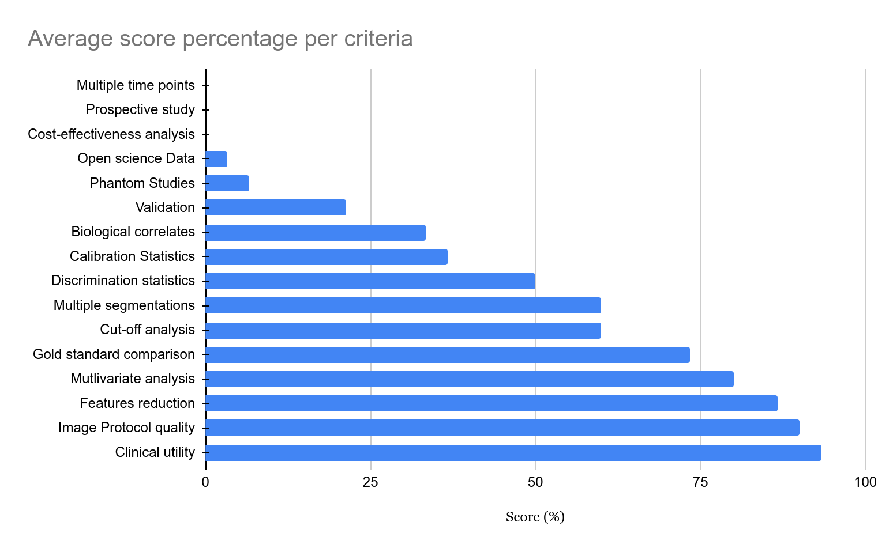

The criteria the less respected by the different reviewed studies were all those related with the reproducibility and the robustness. Among them, the analysis of images acquired at multiple times, the implementation of phantom studies to detect inter-scanner differences and features sensitive to those settings, or even the prospective design of the studies that will ensure inclusion of patients undergoing the same protocols were almost always neglected.

Even though the different reviewed studies obtained successful results in regards with the wanted task, their robustness relative to the experimental settings and their reproducibility can be questioned, especially when analyzing their results obtained on the radiomics quality scoring system [**Lambin 2017**].

One way to allow a better reproducibility for the future radiomics studies is to fulfil the maximum possible criteria introduced by the *RQS* standard, and to use standard ways to compute the quantitative features, thanks to open-source libraries such as pyradiomics [[**van Griethuysen et al.**](https://pyradiomics.readthedocs.io/en/latest/) **2017**]. Another way is to reduce as much as possible the impact of human-based interpretation in the *HCR* workflow. This can be done by replacing the hand-crafted annotations, and the engineered process of features computation and selection by a standardized, automated and data-driven pipeline, similar to what is performed in more recent *DLR* studies.

## Deep Learning Radiomics

In this section we will first present the differences between the *HCR* and the *DLR* strategies, before describing in detail the *DLR* concept. We will then present the different reviewed studies tackling liver-related problems using a *DLR* approach. We will outline the different steps of their pipelines such as the use of multiphasic images, the way they incorporated experts’ annotations and their choice regarding the deep network architectures.

### Difference between HCR and DLR

Being a young field, radiomics starts to mature when applied to several organs such as the lungs or the breast, but it still struggles when applied to the liver, especially because of the scarcity of available data and the complexity of its anatomy.

As exposed previously, the first studies targeting liver cancer almost always rely on hand crafted features (*HCR* : Hand-Crafted Radiomics).

The main limitation observed is the lack of reproducibility originating from engineered features, that sometimes result from complex processes which can be difficult to imitate, and often fail to work on different databases.

*HCR* rely on manual or semi-automatic expert annotations, which often require a complex and time-consuming process, that also provide several constraints, such as the poor inter-expert reproducibility.

The extracted features are not necessarily relevant to encode the observed structure, it is needed to increase their number, hence requiring a complex dimensionality reduction step.

Another limitation is the difficulty to find the perfect association between features extraction, selection and the statistical analysis used to reach the wanted target.

Those limitations, and the rise of new computational resources associated with the emergence of deep learning techniques allowed the development of a new branch in the radiomics field, called *DLR* (Deep-Learning Radiomics) [**ref Afshar et al. 2019**].

### DLR workflow

In this branch of radiomics, the features are extracted through a deep-learning process, avoiding a manual extraction.

A neural network can be trained to generate the most relevant features. These features can either be kept in the network for the final pathological target prediction, or used as input in a different model (such as a SVM or a RF).

Compared to the *HCR*, no prior knowledge is required, and the features can be extracted in an end-to-end manner, using only the raw images as input, and without necessarily providing any segmentation. It has also been demonstrated that performances of those networks increase with the size of the training dataset [**ref Cheng et al. 2016**].

Eliminating the segmentation phase when evaluating the diagnosis, allows to reduce the workload of experts, and provides a solution to the observer-dependency.

When training *DLR* networks, the original image can be combined with the segmentation or any other pre-processed step result such as the gradient image for example [**ref Sun et al. 2017**] to improve the relevance of the extracted features.

Generally, *DLR* studies can be classified depending on the type of input used, the training strategy or the type or architecture choosed to extract the features.

As input, deep radiomics networks can consider 2D slices independently, however this technique does not bring sufficient information since the decision mainly depends on the entire volume of interest.

The different outputs obtained in a slice-wise fashion can be fused to get a volume-wise decision. The volume by itself can also directly be used as input, however it can raise several issues such as the size of the voxels or the slice thickness. Finally, the classification can be performed by considering a series of volumes corresponding to the entire examination of the patient [**ref Shen et al. 2016**], but here again the question regarding the normalization of the input can be raised.

Once the type of input is chosen, the studies differ depending on the training strategy. The networks can be trained *from scratch* using only the available data or a pre-existing architecture can be utilized. In the first case, the obtained network will be specific to the wanted task, but this specialization can also lead to troubles such as overfitting or the sensitivity to imbalance data.

The impact of those problematics can be limited with the help of data augmentation (use of existing data to generate new artificial samples) [**ref Kumar et al. 2017**], multi-task training (where the number of parameters is limited by the training of several task using the same network) [**ref Jamaludin et al. 2016**] or the incorporation of the proportion of each class present in the data when building the cost function [**ref Jamaludin et al. 2016**].

The other strategy consists in using an architecture pre-trained most of the time on natural images, and then re-train only a specific part on the wanted task [**ref Echaniz, Huynh, Paul 2017- 2016**]. It is worth noting that this type of training constrains the pipeline to be slice-wise since existing architectures are often pre-trained on 2D images.  
Finally, the features can be extracted using either a supervised or an unsupervised approach. In the supervised case, the most commonly used networks are based on convolutional layers (*CNN*), followed by one or multiple dense layers to predict the output class. While the network is trained to perform the classification, the features are extracted either after a fully connected layer [**ref Paul et al. 2016**], or after one of the convolutional layers [**ref Li et al. 2017**].  
Other variants that are also built with convolutional layers as key components can also be implemented (*RNN*, *LSTM* or *Capsule Net*). Their goal is to get rid of the limitations caused by the input format that need to be fixed, and by the difficulty to consider an entire 3D volume during the training [**ref Azizi et al. 2018**].

In the unsupervised case, the objective is to let the extracted features be responsible for the data distribution, so that new cases can be created following this distribution. The most commonly used architecture in this case is the *auto-encoder*, made up with a part that contracts the information (encoder), in order that the most useful one is conserved to regenerate the original data (decoder). Auto-encoder can be built on top of convolutional layers [**ref Echaniz et al. 2017**], or trained with the aim of being insensitive to the noise added to the input data [**ref Sun et al. 2017, Kim et al. 2016**]. Following the same principles which are to reconstruct the original input data using only the most relevant features, some studies implemented *DBN* (Deep Belief Networks) **[ref Sun et al. 2016]** or Deep Boltzmann Machines [**ref Suk et al. 2014**].

Some studies are referred to as hybrid, when features are combined with other sources of data (combination of different modalities [**ref Oikonomou et al. 2018**] or association with clinical data such as genomic data [**ref Emaminejad et al. 2016**]), or when only a part of the pipeline implements deep learning methods, either for the extraction of the features [**ref Paul et al. 2016**] or when the decision is taken with a fusion between *HCR* and *DLR* features [**ref Huynh et al. 2016**].

### DLR applied to the liver

Even though the number of studies targeting the liver is increasing, the vast majority of them can be categorized as *HCR*, and only a few are currently based on deep learning.

The main reason behind that is the late emergence of deep learning and the recent outbreak of new architectures and concepts that are often first developed and evaluated in other fields than the medical imaging one (e.g. Residual Network, DenseNet, Capsule Net).

#### Study Endpoint

Within the reviewed *DLR* studies, the majority of them are targeting a diagnosis, either the classification of *FLLs* (Focal Liver Lesions) [**Yamada et al. 2019, Wang et al. 2018, Yasaka et al. 2018, Liang et al. 2018**] or the estimation of the fibrosis stage [**Yasaka et al. 2018**], when two of them focused on the response to treatments, either for recurrence after resection [**Wang et al. 2019**] or the response after *TACE* [**Peng et al. 2019**].

We selected the studies using *CT* images to perform their analysis, and realized that the vast majority of them used multiphasic images to perform their research, knowing that the evolution of contrast medium is often correlated with the pathological features of the liver as mentioned in the **Medical Context**. The only one that used single phase images, was the one targeting an estimation of the fibrosis stage, and their method was based on portal phase images only [**Yasaka et al. 2018**]. Regarding the multiphasic studies, there is no consensus about the delay between the injection of the contrast agent and the acquisition of the different phases. They tend to prefer triphasic acquisition, with images acquired before the injection of contrast agent, at early arterial phase and a third phase, either portal venous [**Wang et al. 2018, Liang et al. 2018, Wang et al. 2019**] or a delayed one [**Yamada et al. 2019, Yasaka et al. 2018**]. **Peng et al.** decided to get rid of the *NECT* (non-contrast-enhanced) phase, but still chose a triphasic acquisition (*AR, PV, DELAY*).

#### Image processing pipeline

Concerning the image processing pipeline, the data used to train the deep networks are most commonly selected via placement of a bounding box by the experts around the hepatic lesion, before a registration between the different phases in case of multiphasic acquisition to counter the effects of body motion and/or breathing.

The manual placement of the *ROIs* is usually done by one or more experts on the raw image [**Yamada et al 2019, Wang et al. 2018, Yasaka et al. 2018a, Wang et al. 2019, Yasaka et al. 2018b**], and only one study decided to perform an automatic segmentation of both the parenchyma and the lesion with the application of a random-walker algorithm, before being checked by experts [**Liang et al. 2018**]. When the method is based on a 2D approach, selected images are often those presenting the maximal cross-sectional proportion of the lesions, except one study targeting the estimation of the fibrosis stage, that centered the *ROI* so it displayed the ventral aspect of the liver [**Yasaka et al. 2018b**]. Only one study incorporated 3D information in their pipeline, but they also started the placement of the *VOI* with the slice presenting the maximal proportion of tumor, and extended it to adjacent slices [**Yang et al. 2019**].

After placing a bounding box, the images are registered either manually [**Yamada et al. 2019, Wang et al. 2018, Wang et al. 2019**] or via the application a non rigid registration with anatomical constraints [**Liang et al. 2018**]. No real registration was mentioned for two studies [**Peng et al. 2019, Yasaka et al. 2018b**] but Yamada et al. evaluated the effects of the registration in the prediction performances of their networks (as depicted in the figure below), and after training several networks with misregistered data (shifted, rotated, skewed) they concluded that in the vast majority of the cases, no statistical significance can be found between the performances of the networks trained with manually registered data and those of the networks trained with misregistered data [**Yamada et al. 2019**].

|  |
| --- |
|  |
|  |

Worth noting that some studies performed their analysis on cropped or resized JPEG images [**Yasaka et al. 2018a, Yasaka et al. 2018b, Wang et al. 2019**]. This choice might cause loss of data, since RGB channels are encoded with 256 values whereas the raw data is used elsewhere, where the liver HU intensities are often in the range [-100, 400HU].

#### Training strategies

Finally, in the reviewed studies, only two of them combined images with clinical data [**Yasaka et al. 2018b**, **Wang et al. 2019**], whereas the other only used image data, which is understandable because clinical data are often difficult to retrieve, and can also be difficult to integrate in a deep network, as illustrated in the figure below.

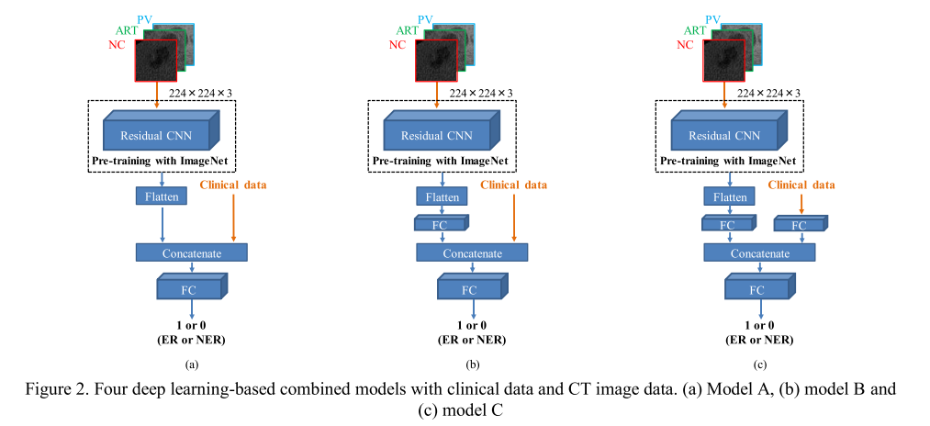

The reviewed studies differ mainly in the way they built their deep architecture.

In most of the cases, convolutional layers are used for the extraction of the most discriminant features. The main question being whether to use a pre-trained network or to train a network from scratch. In the case of fine-tuning, the most commonly used architectures are *AlexNet* and *ResNet* [**Wang et al. 2018, Yamada et al. 2019, Wang et al. 2019, Peng et al 2019**], but it is also usual to compare the results obtain by different pre-trained architectures [**Wang et al. 2019a, Yamada et al. 2019**]. The general method is to recycle an architecture trained on a huge dataset such as ImageNet, freeze the weights of the early layers (responsible for the high levels features), adjust and train the last layers on the current database to be more specific.

An illustration of this process can be found in the figure above [**Yamada et al. 2019**].

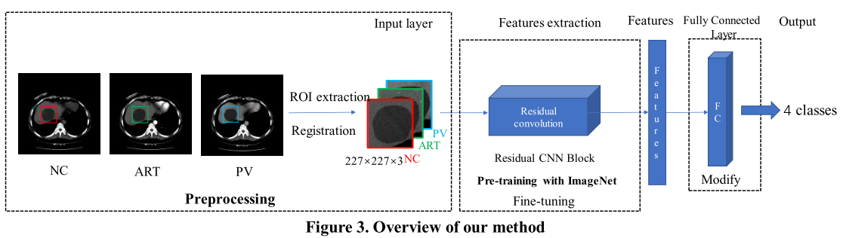

The rest of the reviewed studies created a custom architecture and trained it from scratch [**Yasaka et al. 2018a, Yasaka et al. 2018b, Liang et al. 2018**].

Two of them used classical convolutional layers followed by max pooling layers, early in the network to extract relevant features, as depicted in the figure below [**Yasaka et al. 2018a, Yasaka et al. 2018b**].

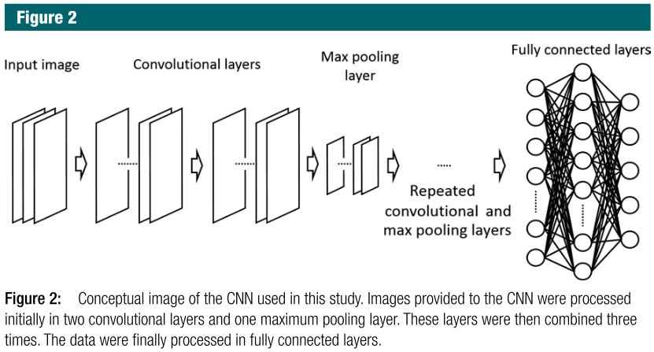

Since multiphasic studies often stacked the different phases as channels to feed the deep network, one study decided to extract the temporal information through a different paradigm by using *LSTM* (Long Short Term Memory) layers [**Liang et al. 2018**]. As depicted below, their architecture first extracted the features using what they called a “ResGLBlock” per phase, with two scaled data as input (a large one with the entire lesion, and a smaller one with finer details), and conserved the temporal information via bidirectional *LSTM* layers.

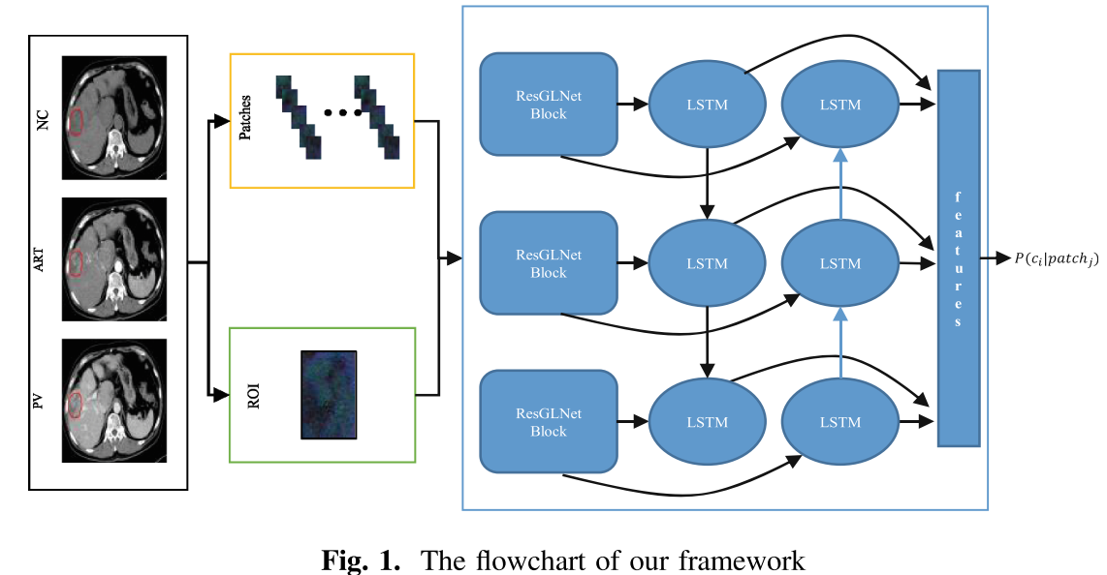

When using a pre-trained architecture, the input size is often dictated by the native architecture (224x224x3 for example for the ResNet architecture [**Peng et al. 2019, Wang et al. 2019b**]), and the different studies need to resample their inputs to fulfill those requirements, which can sometimes affect the performances of the network, whereas custom architectures allow a usage of custom sizes [**Yasaka et al. 2018a, Yasaka et al. 2018b, Liang et al. 2018**]. However, the size of the lesions or other extracted *ROI* is often different from one patient to the other, therefore, this problem is still open.

One way to render the deep networks robust to those changes is through data augmentation. Yasaka et al. 2018a for example trained the network with patches cropped at different resolutions from the initial lesion *ROI* after application of standard geometrical transformations such as rotation or shift [**Yasaka et al. 2018a**]. The same process of extracting different patches from an initial ROI is performed by two other studies, where the goal is also to balance the different classes [**Yasaka et al. 2018b, Peng et al. 2019**].

The networks are then usually trained in a cross validation fashion [**Yamada et al. 2019, Yasaka et al. 2018a, Yasaka et al. 2018b, Wang et al. 2019**], or validated on external dataset [**Peng et al. 2019**] to be less affected by the effect of randomness, and to be less prone to overfitting.

#### Performances

Regarding their performances on their testing sets, the different studies concluded first that fine tuning allows an improvement in the accuracy of the *DLR* network, when compared to training from scratch (e.g. Wang et al. reported an improvement from 83.7 to 91.2% regarding the classification accuracy of their model when using a pre-trained network) [**Yamada et al. 2019, Wang et al. 2018**]. Several studies also demonstrated that multiphase images increase the performances or the *DR* networks, when compared to single phase input only [**Yasaka et al. 2018a**]. Instead of training the *DR* networks only with images, it is possible to combine them with clinical data which can be difficult to collect, and challenging to integrate in a deep architecture, but are proven to improve the accuracy of the networks in some cases [**Wang et al. 2019**].

Reported results showed moderate to good accuracy for the wanted tasks. For example, the reported mean accuracy is above 0.90 for the studies targeting a classification between Focal Nodular Hyperplasias, Cysts, HCC and Hemangioma (0.91 in both **Liang et al. 2018 and Wang et al. 2018**), and it slightly drops to 0.84 when more complex categories are integrated (iCC, combined HCC and difference between HCC and early HCCs) [**Yasaka et al. 2018a**]. Another study performed the classification between HCCs and non HCCs, by additionally incorporating the differentiation stages for the HCC group, but still had comparable performances than experienced radiologists in the diagnostic performances [**Yamada et al. 2019**].  
The study targeting the estimation of the fibrosis stage reported results less accurate than those obtained using elastography data (*MRE*: Magnetic resonance elastography or *TE*: Transient elastography), but they were the first to perform this analysis on CT images, and their results could be improved with the inclusion of volumetric information, and other sources of data. [**Yasaka et al. 2018b**].

Finally, the studies predicting a response to a treatment reported a high accuracy with an AUC of 0.82 when predicting the recurrence after TACE [**Wang et al. 2019**], and accuracy above 0.83 in the two external validation sets when estimating the response of TACE in HCC [**Peng et al. 2019**].

Those results still can be improved, especially by increasing the size of the cohort, or by replacing the manual placement of the bounding boxes with an automatic segmentation method in order to reduce the dependency to single or multiple experts [**Yasaka et al. 2018b, Peng et al. 2019**].

As a conclusion, the different reviewed studies tend to agree on the fact that a multiphase analysis is necessary to precisely describe and encode the pathological features of the disease. For the rest of the pipeline, no real consensus exists but several strategies are implemented especially to compensate for the small size of the databases. Worth also noting that the reviewed studies correspond to the first DLR liver-related applications, therefore, they tend to tackle the less complex problems such as the FLLs classification. With future improvements regarding DL applied to the medical imaging field, and with more publicly available data, the next DLR liver-related studies will be ready to tackle more complex challenges.